This template provides high level data to be collected from investors to help us understand their Investor Preferences
Please share your investment preferences below so that we can tailor our outreach around the ventures that most interest you.
When you submit this form, it will not automatically collect your details like name and email address unless you provide it yourself.
Required
1.Your Name
2.Your Email
3.Your Organization
4.Please select the sectors in which you actively invest.
Health
Climate
EdTech
Future of Work
FinTech
5.Please select the stage/s at which you actively invest.
Pre-Seed
Seed
Series A
Series B
6.Please select the region/s in which you actively invest.
USA
Sub-Saharan Africa
Latin America and the Caribbean
7.If you have a particular geographic focus in the region/s noted above, please describe it here
8.Please select the option that represents your typical check size.
$0-$100,000
$100,000-$250,000
$250,000-$500,000
$500,000-$1,000,000
> $1,000,000
9.Please select the type of capital that you are currently deploying.
Equity
Debt
Grants
10.Please share any other details about your investment preferences that will help us better match you with aligned companies (i.e. sub-sectors within Health or Climate, minimum ARR requirements, valuation range, etc)
11.Would you also like to receive the full list of Halcyon alumni investment opportunities?
Yes
No
Submit
Never give out your password.Report abuse
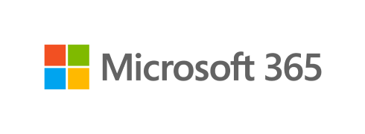
This content is created by the owner of the form. The data you submit will be sent to the form owner. Microsoft is not responsible for the privacy or security practices of its customers, including those of this form owner. Never give out your password.
Microsoft Forms | AI-Powered surveys, quizzes and pollsCreate my own form
The owner of this form has not provided a privacy statement as to how they will use your response data. Do not provide personal or sensitive information. | Terms of use

